**1.Write a c program to convert infix to postfix**

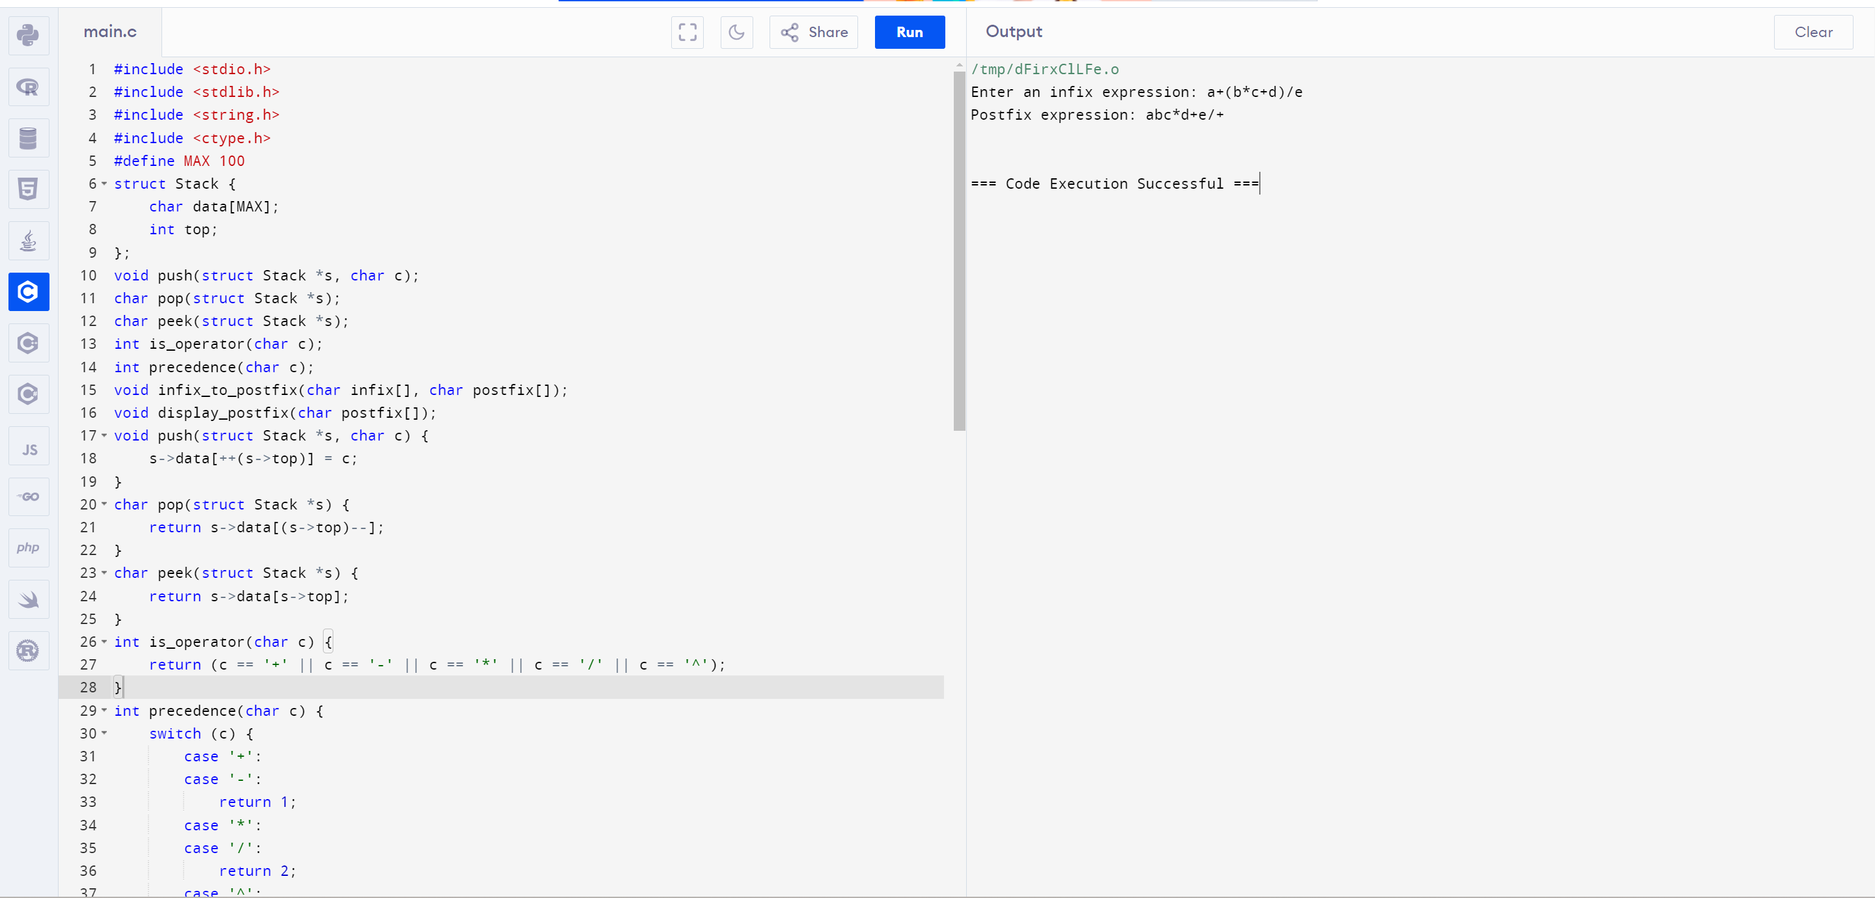

**2.write a c program to convert postfix to infix**

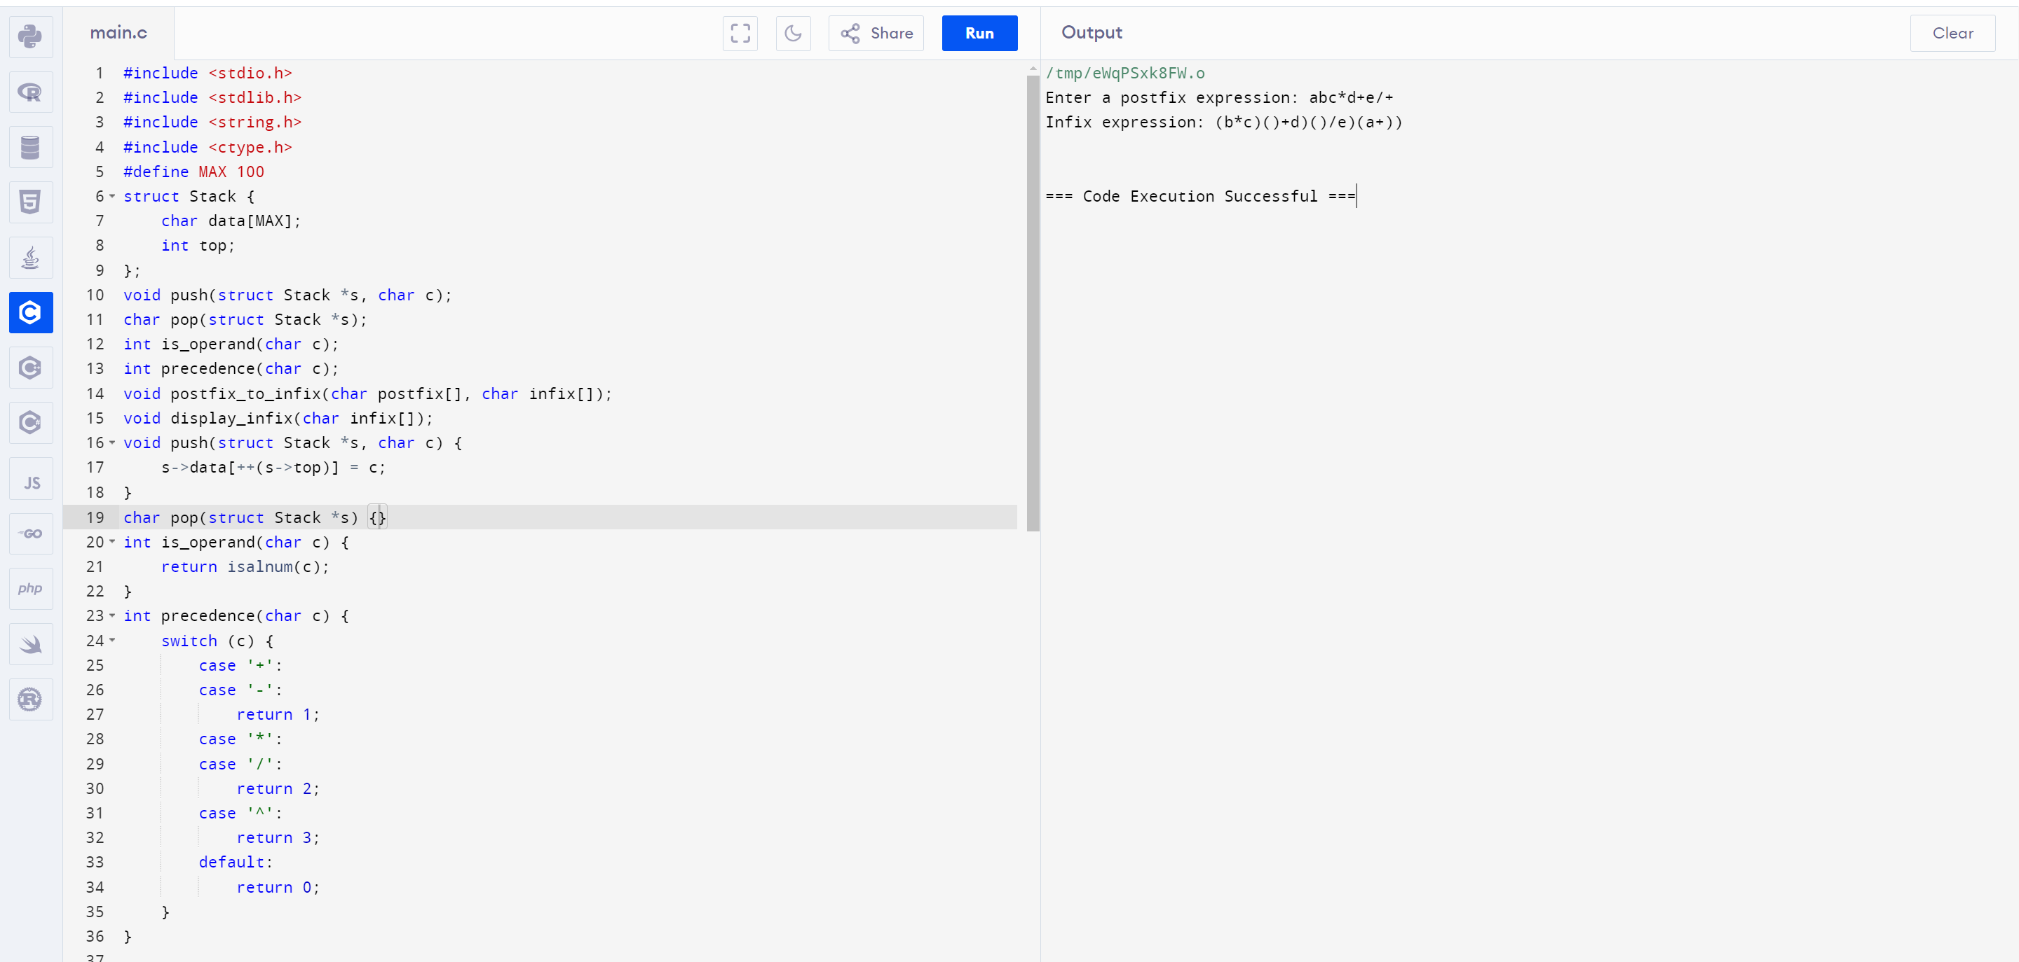

**3.Write a c program for balancing symbol**

